# Exporting results from the SQL Results view to a file

After running the SQL script on a database, you can export the results to a file on the file system. Several file formats are supported, including *.csv, so that you can capture the results in external tools such as spreadsheets. This method can be useful if you want to more easily share results information with team who do not have the workbench installed.

## Procedure

To export results from the SQL Results view:

Right-click anywhere in the Results tab, and select Export > Current Result or Export > All Results

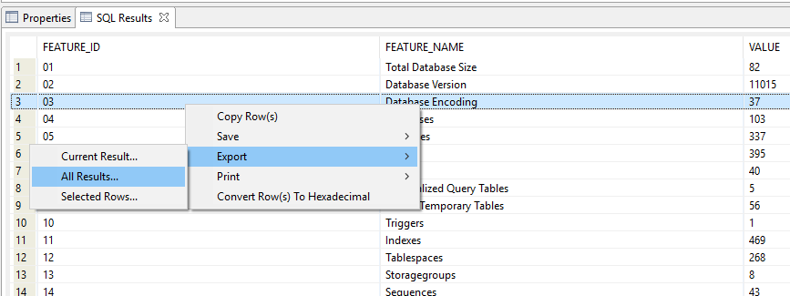

Select a file folder in which to save the result set, enter a file name and file type as CSV, and specify export option as CSV File. If you don’t specify a file location, the file is saved to the <installation>\eclipse directory.

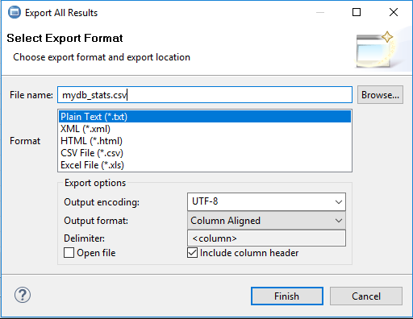

Click Finish.

## Results

The result set is exported to the file that you specified. You can copy the file from the file system and send the CSV file.